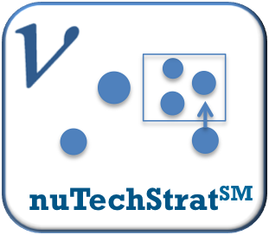
Aligning portfolios – Technology strategy

A nu Angle briefing

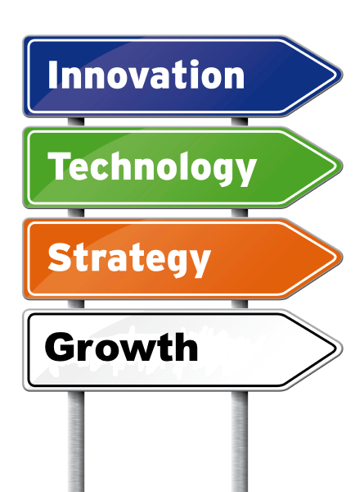
Sustainable innovation-led growth is the goal of most companies. Knowing how to deliver it is an entirely different matter. A key part of sustainable innovation is the ability to invest in enabling technologies in a timely manner, in support of commercial plans. Balancing resources and maintaining critical mass in key areas of technology is a fine balancing act that most executive teams find challenging – mostly because they don’t have the right kind of information to hand, and the commercial and R&D teams do not have a mechanism to share priorities and plans together in way that is meaningful for both of them.
Developing a well-structured technology strategy can alleviate these problems. In the past, Technology strategy was solely in the domain of high technology companies. This no longer the case, with technology becoming ever more pervasive, and improved approaches in technology management making the necessary toolset more accessible to a wider audience.
This briefing describes in a few words how to use technology strategy to radically improve your investment plans to achieve sustainable innovation-led growth.

Benefits to creating a technology strategy
There are many benefits to creating a good quality technology strategy and the relative importance for each will depend individual circumstance.
- Create an aligned set of priorities across the commercial and technical teams within your organization
- Pinpoint gaps, confirm areas of strength and identify opportunities for accessing technology from external partners to support commercial growth plans
- Protect against disruption from unexpected changes in technology
- How to spread risk across a balanced portfolio
- Make investment choices based on a validated view of technology priorities and resources required to access this technology
- Reduce development costs through less wasted effort
- Solid basis for capability development decisions – agreeing what is essential to keep ‘in-house’ and what can be sourced externally

What’s important in building a technology strategy?
Technology and strategy are words that conjure up images of high technology, software and IT. In fact, it is a set of fairly straightforward tools assembled to provide the basis for linking the commercial needs of any business with enabling technology – product, service, or delivery. Many sectors are now in real need of a way to build the dialogue between customer-facing teams and the R&D organization that need to deliver solutions to the needs and insights that are identified.
What’s required is an approach to technology strategy that is solidly grounded in the needs of the business, builds bridges between different areas of the business, and provides transparent links between commercial priorities and a realistic portfolio of technologies. It should also build scenarios that are commercially relevant, and describes choices and investment plans that help senior executives make confident decisions.

Outline of approach to technology strategy
The essential elements of technology strategy are fairly straightforward – build a picture of how technology could support commercial needs and then translate this picture into a prioritized set of plans for implementation. Sounds simple. However, similar to roadmapping, technology strategy has not had the impact it could have had across a broad range of industries. It has, in our opinion, been limited by a focus on technology and not enough emphasis on the impact required – namely decisions on what technologies are important and how to acquire them, plus a direct connection to the needs and insights that they will fulfill.
Building a technology strategy is not just about scoring technologies and selecting the highest priority using some algorithm. It is about building a rationale about what technologies are important to your business – this involves using a combination of commercial and technical criteria, interpreting 2D plots of these criteria (see below), plus an analysis of overall scoring. We have well-developed approach to selecting which charts to use – each client’s requirements differs slightly - and have some benchmark materials that help us interpret the data they produce.
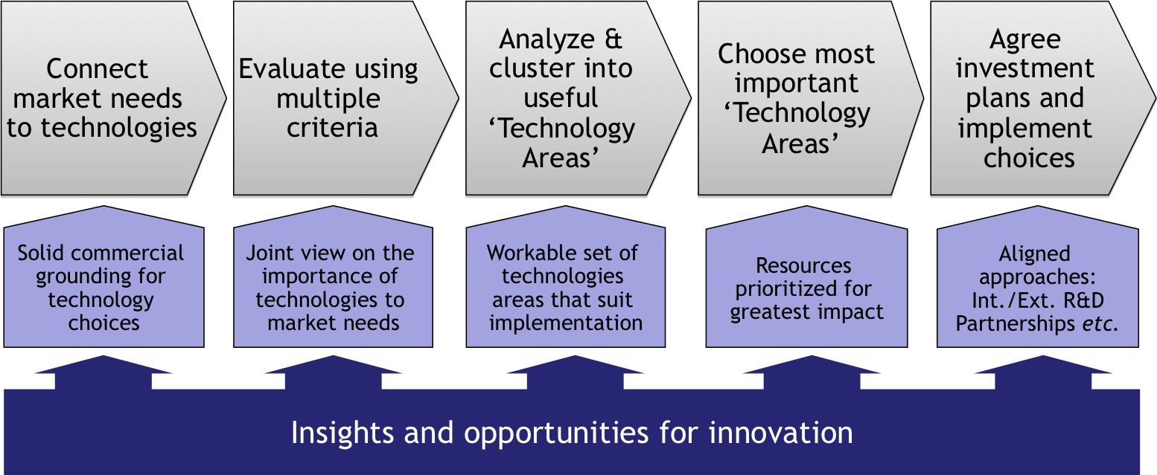
A well-executed technology strategy should provide benefits at every stage of its development. It should support a constructive dialogue between commercial and R&D teams, and provide a solid basis for executive teams to make real choices. The process should also enable you to develop further insights and opportunities throughout. If it is not doing this then you’re probably not pushing your strategy approach hard enough.

Distinctive features of nu Angle’s approach to technology strategy
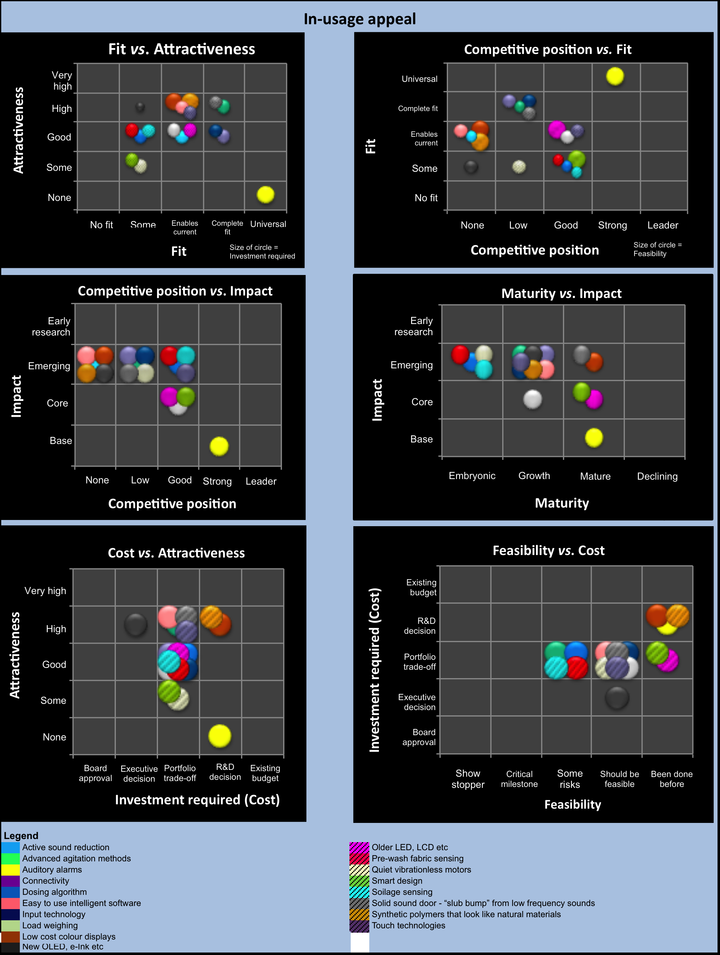
At nu Angle, we have worked in technology and innovation management for over a quarter of a century and have watched technology strategy emerge as a tool for technology rich companies. In recent years, use of the approach has broadened immensely and brought with it a need to expand the tool beyond the arena of R&D. Consequently, we have devised an approach that starts with the commercial priorities of a business and builds investment scenarios to enable executive teams to make clear choices. We are also conscious that companies want to move as quickly as possible to implementation. The scenario building involves resourced action plans – executives can then make informed choices based on resource and cost estimates for implementation. A realistic choice, rather than a ‘wish list’ that is impossible to fulfill. The following are unique features for our technology strategy approach:
- MS Excel strategy tool that covers initial scoping, expert input, IP analysis, strategy development creation, scenario planning and bundled implementation work packages
- Focus on integrating commercial priorities and strategy throughout the technology strategy process
- Highly efficient data capture process enabling us to make data collection and analysis as efficient as possible.
- Emphasis on good technology content, the creation of insights, innovation and practical implementation throughout the process
- Executive-friendly outputs in terms of scenario plans and investment profiles where the technology strategy details are the supporting material, rather than the central focus of decision-making
For more information, contact: Dr Peter Allen – peter.allen@nu-angle.com, +44 1923 268922

